Title
FIRSTNAME Lastname, FIRSTNAME Lastname, FIRSTNAME Lastname
Abstract
A single paragraph of about 400 words maximum. For research articles, abstracts should give a pertinent overview of the work. We strongly encourage authors to use the following style of structured abstracts, but without headings:
1) Background: Place the question addressed in a broad context and highlight the purpose of the study
2) Methods: Describe briefly the main methods or treatments applied
3) Results: Summarize the article's main findings
4) Conclusions: Indicate the main conclusions or interpretations.
The abstract should be an objective representation of the article; it must not contain results which are not presented and substantiated in the main text and should not exaggerate the main conclusions.
Keywords: keyword 1; keyword 2; keyword 3 (List three to ten pertinent keywords specific to the article; yet reasonably common within the subject discipline.)
0. How to Use This Template
The template details the sections that can be used in a manuscript. Note that each section has a corresponding style, which can be found in the »Styles« menu of Word. Sections that are not mandatory are listed as such. The section titles given are for Original scientific papers. Review papers and other article types have a more flexible structure.
Remove this paragraph and start section numbering with 1. For any questions, please contact the editorial office of the journal at crojfe@sumfak.hr
1. Introduction
The introduction should briefly place the study in a broad context and highlight why it is important. It should define the purpose of the work and its significance. The current state of the research field should be reviewed carefully, and key publications cited. Please highlight controversial and diverging hypotheses when necessary. Finally, briefly mention the main aim of the work and highlight the principal conclusions. As far as possible, please keep the introduction comprehensible to scientists outside your particular field of research. See the end of the document for further details on references.
2. Materials and Methods
Materials and Methods should be described with sufficient details to allow others to replicate and build on published results. Please note that publication of your manuscript implicates that you must make all materials, data, computer code, and protocols associated with the publication available to readers. Please disclose at the submission stage any restrictions on the availability of materials or information. New methods and protocols should be described in detail while well-established methods can be briefly described and appropriately cited.
Research manuscripts reporting large datasets that are deposited in a publicly available database should specify where the data have been deposited and provide the relevant accession numbers. If the accession numbers have not yet been obtained at the time of submission, please state that they will be provided during review. They must be provided before publication.
Interventionary studies involving animals or humans, and other studies require ethical approval must list the authority that provided approval and the corresponding ethical approval code.
3. Results
This section may be divided by subheadings. It should provide a concise and precise description of the experimental results, their interpretation as well as the experimental conclusions that can be drawn.
3.1. Subsection
3.1.1. Subsubsection
Bulleted lists look like this:
- First bullet
- Second bullet
- Third bullet
The text continues here.
3.2. Figures, Tables and Schemes
All figures and tables should be cited in the main text as Fig. 1, Table 1, etc.
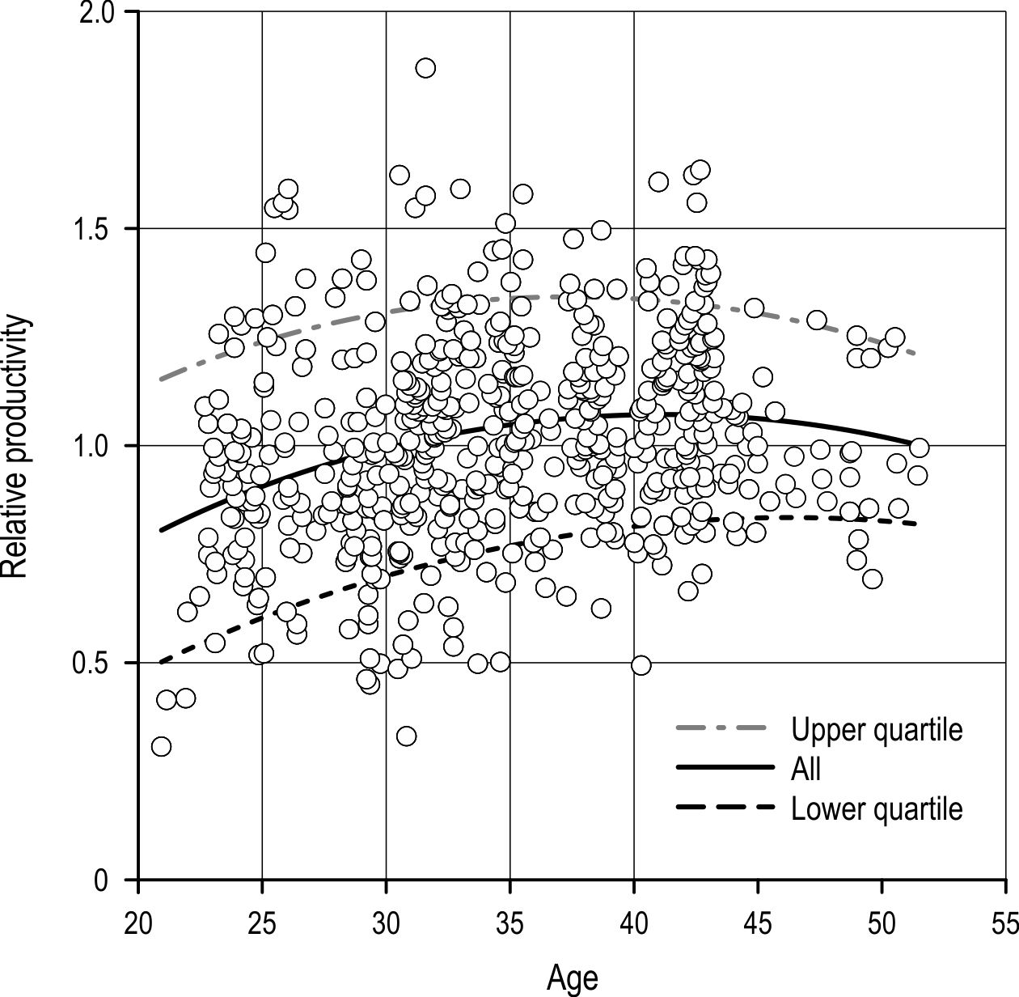
Fig. 1 Figure title
Schemes follow the same formatting. If there are multiple panels, they should be listed as (a) Description of what is contained in the first panel; (b) Description of what is contained in the second panel. Figures should be placed in the main text near to the first time they are cited. A caption on a single line should be centred.
Table 1. Table title
Title 1 | Title 2 | Title 3
entry 1 | data | data
entry 2 | data | data ¹
¹ Tables may have a footer
Tables should be placed in the main text near to the first time they are cited.
3.3. Formatting of Mathematical Components
This is an example of an equation:

$X_{ab}\frac{X_{aa}}{Y_{aa}}=\frac{X_{aa}}{-100.11×{A_{y}}^{x}+100.11×B}$ (1)
Where:
X_{ab} data, m³
X_{aa} data, m³
Y_{aa} data, m³
A_{y}^{x} data, m³
B data, m³.
The text following an equation does not need to be in a new paragraph. Please punctuate equations as regular text.
Theorem-type environments (including propositions, lemmas, corollaries etc.) can be formatted as follows:
Theorem 1. Example text of a theorem. Theorems, propositions, lemmas, etc. should be numbered sequentially (i.e., Proposition 2 follows Theorem 1). Examples or Remarks use the same formatting, but should be numbered separately so that a document may contain Theorem 1, Remark 1 and Example 1.
The text continues here. Proofs must be formatted as follows:
Proof of Theorem 1. Text of the proof. Note that the phrase »of Theorem 1« is optional if it is clear which theorem is being referred to. Always finish a proof with the following symbol. □
The text continues here.
4. Discussion
Authors should discuss the results and how they can be interpreted in perspective of previous studies and the working hypotheses. The findings and their implications should be discussed in the broadest context possible. Future research directions may also be highlighted.
5. Conclusions
This section is mandatory but can be added to the manuscript if the discussion is unusually long or complex.
6. Patents
This section is not compulsory but may be added if there are patents resulting from the work reported in this manuscript.
Acknowledgments
All sources of funding for the study should be disclosed. Please clearly indicate grants that you have received in support of your research work. State if you received funds for covering the costs to publish in open access.
Author Contributions
For research articles with several authors, a short paragraph specifying their contributions must be provided. The following statements should be used »X.X. and Y.Y. conceived and designed the experiments; X.X. performed the experiments; X.X. and Y.Y. analysed the data; W.W. contributed reagents/materials/analysis tools; Y.Y. wrote the paper«. Authorship must be limited to those who have contributed substantially to work reported.
Conflicts of Interest
Declare conflicts of interest or state »The authors declare no conflict of interest« Authors must identify and declare any personal circumstances or interest that may be perceived as inappropriately influencing the representation or interpretation of reported research results. Any role of the funding sponsors in the design of the study; in the collection, analyses or interpretation of data; in the writing of the manuscript, or in the decision to publish the results must be declared in this section. If there is no role, please state »The founding sponsors had no role in the design of the study; in the collection, analyses, or interpretation of data; in the writing of the manuscript, and in the decision to publish the results«.
Appendix A
The appendix is an optional section that can contain details and data supplemental to the main text. For example, explanations of experimental details that would disrupt the flow of the main text, but remain crucial to understanding and reproducing the research shown; figures of replicates for experiments of which representative data is shown in the main text can be added here if brief, or as Supplementary data. Mathematical proofs of results not central to the paper can be added as an appendix.
Appendix B
All appendix sections must be cited in the main text. In the appendixes, Figs., Tables, etc. should be labelled starting with »A«, e.g., Fig. A1, Fig. A2, etc.
7. References
We recommend preparing the references with a bibliography software package, such as EndNote, ReferenceManager or Zotero to avoid typing mistakes and duplicated references. Include the digital object identifier (DOI) for all references where available.
Citations and References in Supplementary files are permitted, provided that they also appear in the reference list here.
In the text, references should be placed in brackets and placed before the punctuation; for example (Surname Year, Surname and Surname Year, Surname et al. Year).

1. Author 1, A.B., Author 2, C.D., Year: Title of the article. Abbreviated Journal Name Volume(issue): page range, DOI.
2. Author 1, A., Author 2, B., Year: Title of the chapter. In Book Title, 2nd ed.; Editor 1, A., Editor 2, B., Eds.; Publisher: Publisher Location, Country, Volume; page range, ISBN.
3. Author 1, A., Author 2, B., Year: Book Title, 3rd ed.; Publisher: Publisher Location, Country; page range, ISBN.
4. Author 1, A.B., Author 2, C., Year: Title of Unpublished Work. Abbreviated Journal Name stage of publication (under review; accepted; in press).
5. Author 1, A.B. (University, City, State, Country), Author 2, C. (Institute, City, State, Country). Personal communication, Year.
6. Author 1, A.B., Author 2, C.D., Author 3, E.F., Year: Title of Presentation. In Title of the Collected Work (if available), Proceedings of the Name of the Conference, Location of Conference, Country, Date of Conference; Editor 1, Editor 2, Eds. (if available); Publisher: City, Country (if available); Abstract Number (optional), Pagination (optional).
7. Author 1, A.B., Year: Title of Thesis. Level of Thesis, Degree-Granting University, Location of University, Date of Completion.
Title of Site. Available online: URL (accessed Day Month Year).

© 2025 by the authors. Submitted for possible open access publication under the
terms and conditions of the Creative Commons Attribution (CC BY) license (http://creativecommons.org/licenses/by/4.0/).

Authors’ addresses:

Prof. FIRSTNAME Lastname, PhD. *
e-mail:
University
Faculty
Department
Street name and house number
ZIP code, City
STATE

Prof. FIRSTNAME Lastname, PhD. *
e-mail:
University
Faculty
Department
Street name and house number
ZIP code, City
STATE

* Corresponding author

Received: Month Day, Year
Accepted: Month Day, Year
Type of the Manuscript (Original scientific paper, Preliminary note, Subject review)

